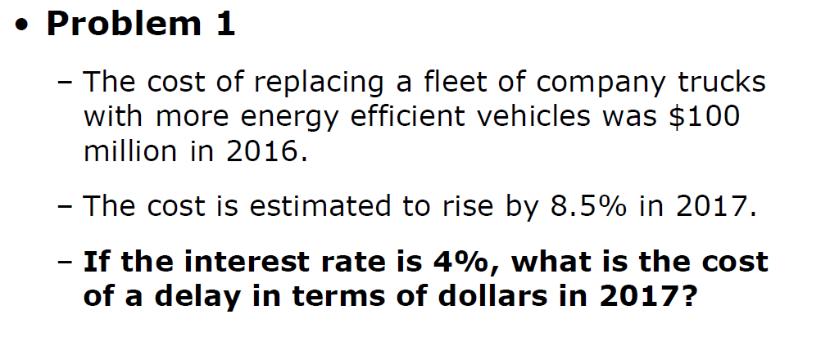

If delayed, cost is $100 million * (1+0.085) = $108.5 million

* Change to 2016’s price : $108.5 million / (1+0.04) (interest rate) = $104.33 million

So cost of delay is $104.33 million - $100 million = $4.33 million

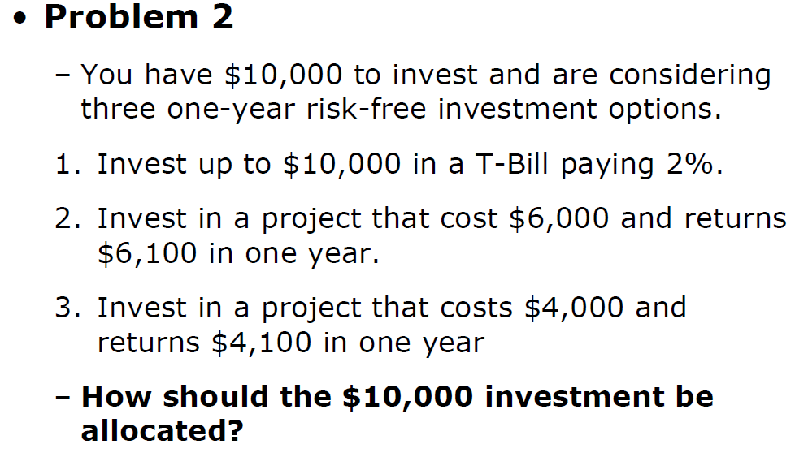

1. Interest rate = 2%
2. Interest rate = $6100 / $6000 = 1.67%
3. Interest rate = $4100 / $4000 = 2.5%

∴ Plan 3 is a best option

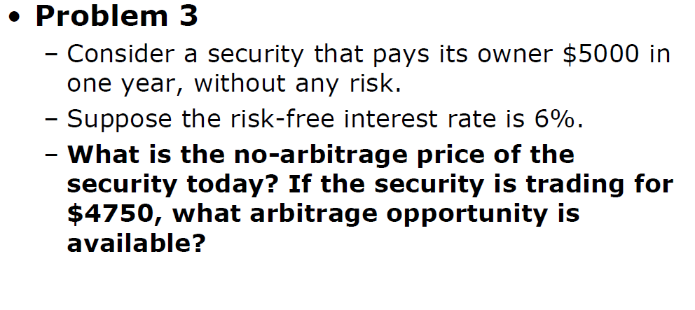

No arbitrage price of the security = $5000 / (1+0.06) = $4716.98

No arbitrage price of the security ($4716.98) < Trading price ($4750)

∴ It's a profit.

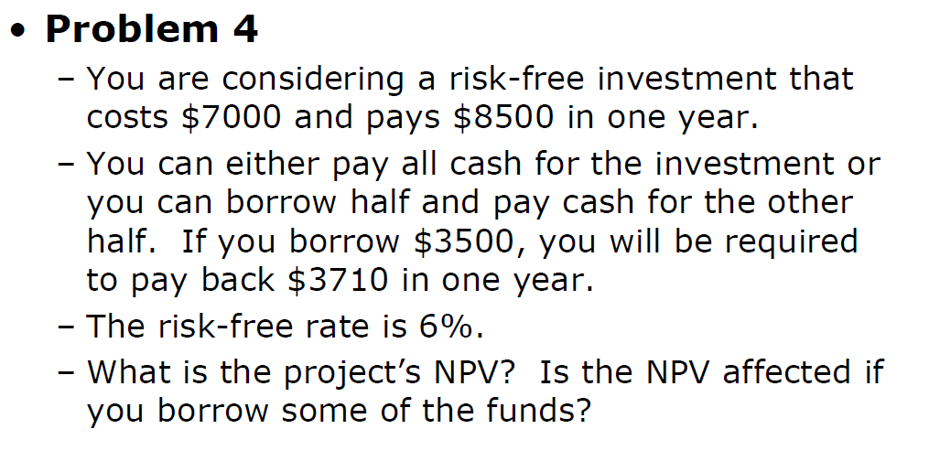

|  |  |  |
| --- | --- | --- |
|  | Year 1 | Year 2 |
| First investment | -$7,000 | +$8,500 |
| Second investment | +$3,500 | -$3,710 |
| Cash Flow | -$3,500 | +$4,790 |
| NPV = -$3,500 + $4,790 / (1+0.06) = $1,018.87 | | |

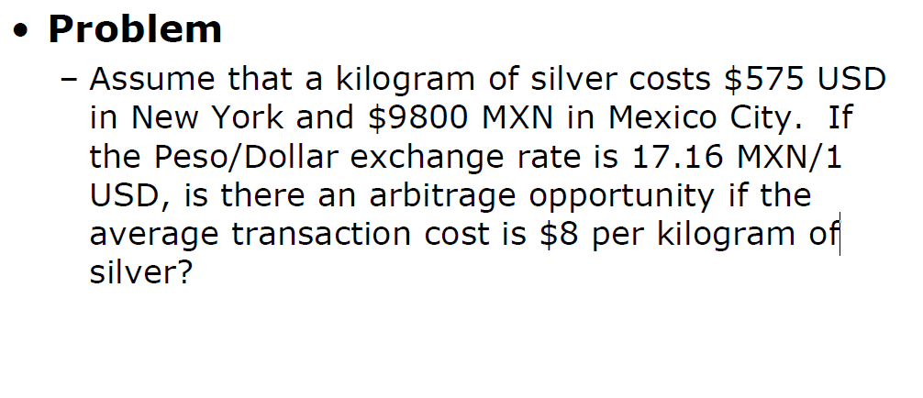

Silver price at New York : 575 $/kg

Silver price at Mexico City : (9800 / 17.16) $/kg = 571.10 $/kg

The different in price is 3.90 $/kg, it is lower than transaction cost $8 per kilogram of silver.

So it is a loss